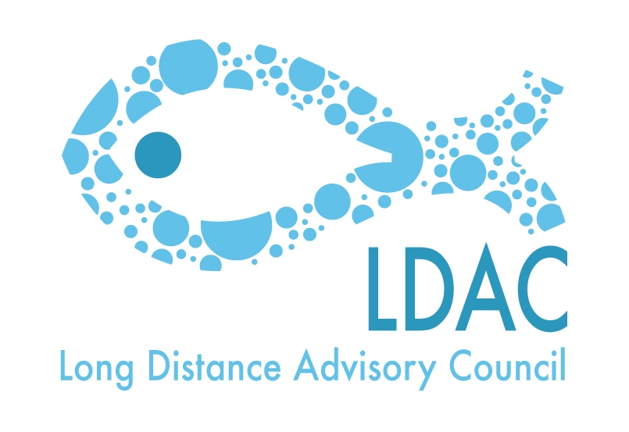
Draft agenda of the
15th Working Group 4 meeting of the LDAC
Bilateral relations with third countries

Wednesday the 15th of October 2014. From 09h00 till 13:00h
Martin’s Central Park Hotel
Boulevard de Charlemagne 80.Brussels

- Welcome.
- Approval of the minutes of 14th WG4 meeting held on the 20th of March of 2014.
- Approval of the Agenda.
- Update of the last negotiations and meetings maintained by the EC relating the agreements with third countries or regions.
  - Agreements in the Indian Ocean (Update on Madagascar, state of negotiations with Mozambique…)
  - Agreements in West Africa. Some points to note:
- Morocco. - Development Application Protocol after September 11, 2014.
- Mauritania.- 4th Round (October 9-10, 2014)
- Senegal. - IEO report hake. Entry into force of Protocol
- Guinea Bissau.- Reopening 2012 Protocol
- Update of the cooperation Project between EU (Canary Islands) and Mauritania (Nouadhibou port operators).
- Horizontal issues.
  - Situation of the different Third Countries regarding the IUU regulation implementation (regulation 1005/2008). Republic of Guinea. - Procedure. Out of the black list of IUU fishing.
  - Harmonization of the access conditions (Project TTI, collaboration with COMHAFAT).
  - Relations between LDAC and STECF. Possibility of being a member of its new composition.
  - Exclusivity clause in the APP. Impact on Protocols instead of Agreements.

- AOB.
- Place and date of the next meeting.
- Closure.

